 | Post | Creative
 | Join H.E Uhuru Kenyatta as he hosts heads of state, development partners, private investors, farmers, youth and more stakeholders at the #AGRF2021 Summit. #foodsystems https://bit.ly/3xVWZp2 | 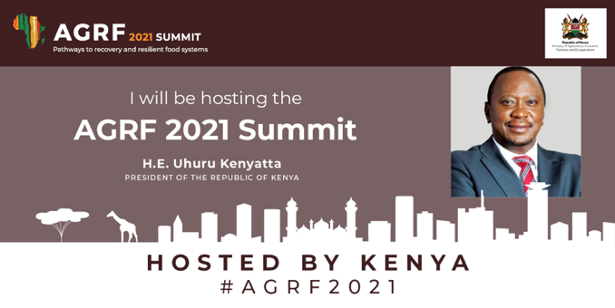
 | Join Kenya as we host heads of state, @theAGRF partners, private investors, farmers, youth and more stakeholders at the #AGRF2021 Summit. #Thisisourtime to transform Africa’s #foodsystems. Register now https://bit.ly/3xVWZp2 | 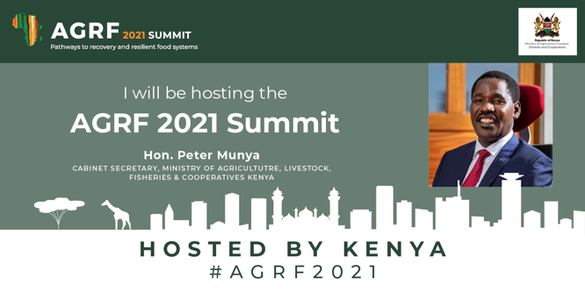
 | Kenya is proud to host the #AGRF2021 Summit from Nairobi, the last stop before the @foodsystems #UNFSS I invite you to join us as we discuss the #PathwaystoRecovery to resilient # foodsystems on 7-10th Sept. Register here https://bit.ly/3xVWZp2 and attend the Summit from wherever you are for FREE! | 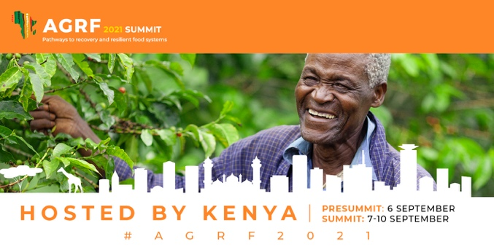
 | Now is the time for the youth of Africa to be heard and to take part in the transformation of Africa's agriculture. Join the conversation #AGRF2021 Summit and register now https://bit.ly/3xVWZp2 to be part of the conversation. #unfss #sdgs | 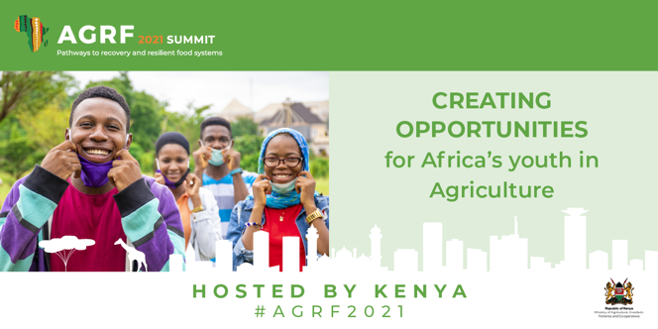
 | The #AGRF2021 Summit is about to begin. Join us on Monday to begin 5 days where heads of state, @theAGRF partners, private investors, farmers, youth and more stakeholders join together to discuss how we can transform Africa’s #foodsystems Register now https://bit.ly/3xVWZp2
AGRF 2021 Posts – Ministries

